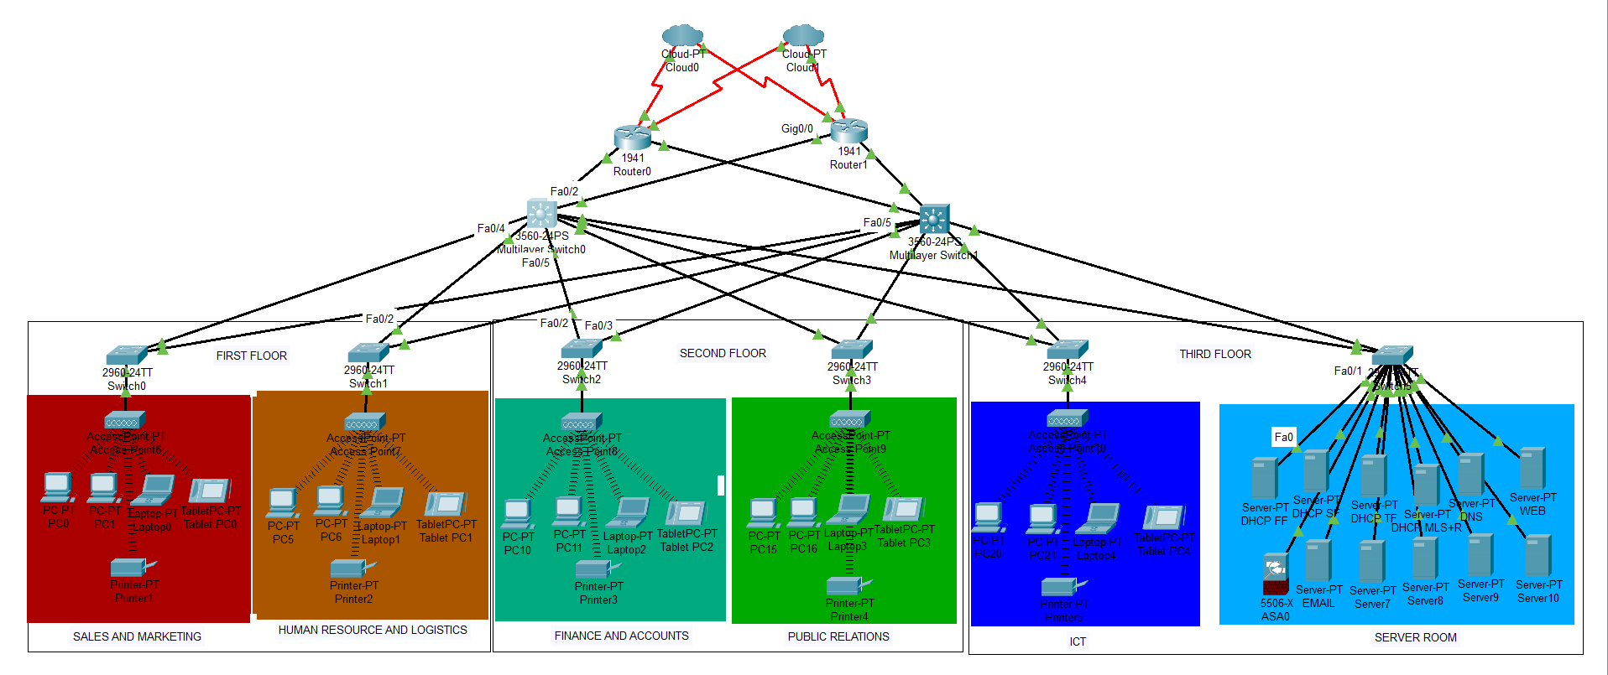

Above is a network architecture design in line with the with the requirements of Altschool Learning Institution; a hierarchical network model with 2 ISPs(cloud 0 and cloud1), core routers, distribution layer multilayer switches and an access layer that includes the three floors each floor contains the required departments configured with access points connected to switches for efficient connection within the network.
Each Department contains devices to represent the design and connectivity of the would be department with the server room containing 11 servers which includes aDHTP FF(First floor), DHTP SF(second floor) DHTP TF(third floor); a firewall and others(functions customisable), for the 12 devices

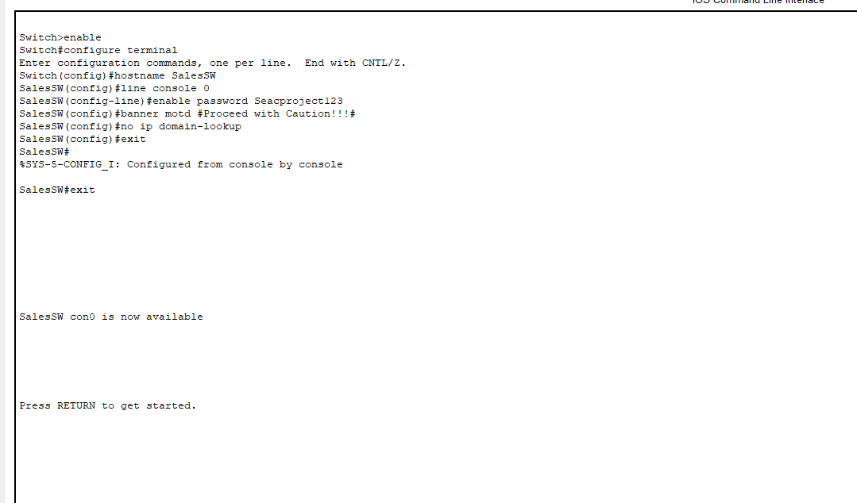

This image shows the basic configuration of the hostname, line console and enable password, banner message of the day, and a no ip domain-lookup which generally disables DNS server functionality

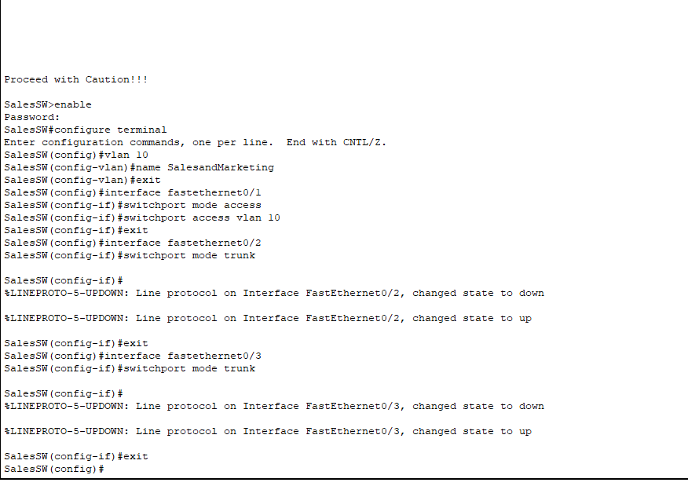
This shows the success of the banner message of the day and also the request of password previously set. Vlan is named and numbered for the department and also given port access on the interface connected to the access point. The switch is then given trunk functionality on the interfaces connected to the multilayer switches.
This exact process is repeated for the other 4 department and server room servers

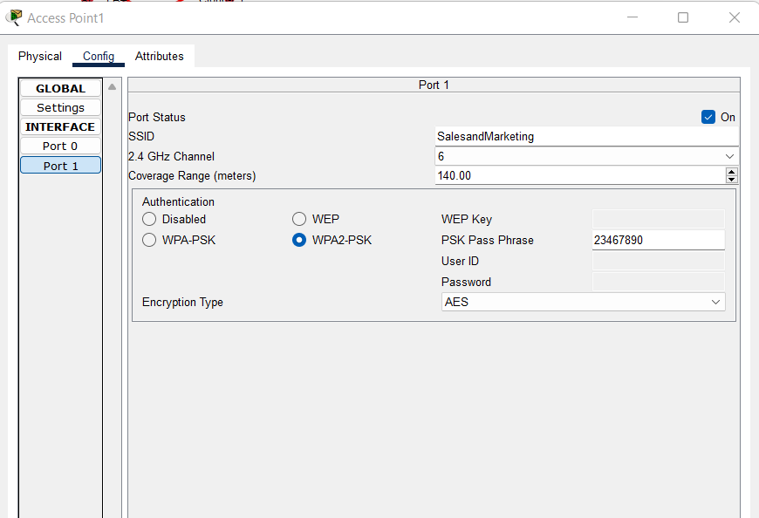

The wireless port 1 of the access points are configured with SSID being the departments name and a WPA2-PSK(wireless protected access 2- pre shared key) pass phrase inputed

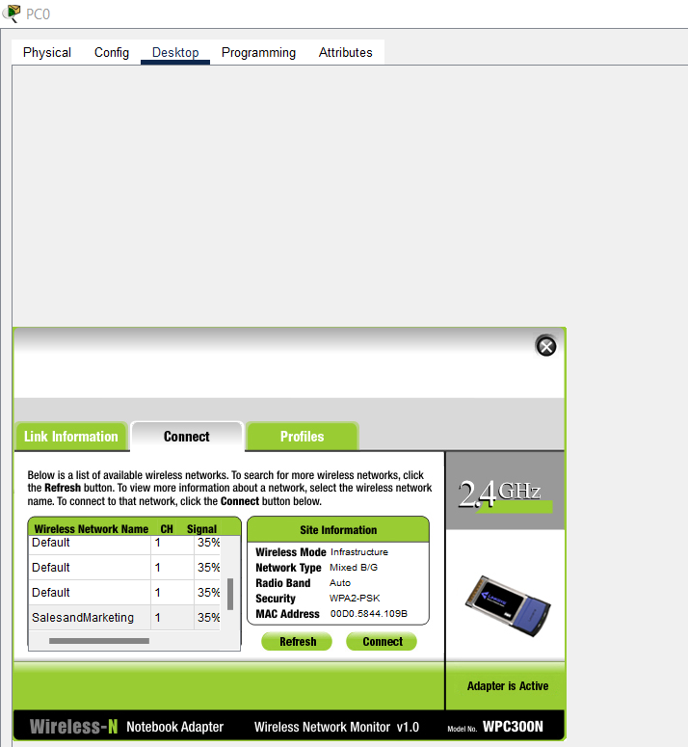

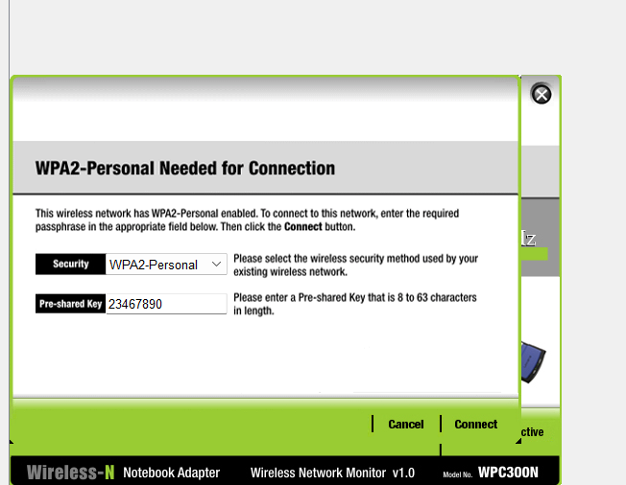

The access point name that corresponds to the department in question is selected and the passkey from the access point configuration is entered to enable a wireless connection within the departments from PCs, printers and laptops to the access point and from access point to switch, ultimately connecting the department user devices to the switch

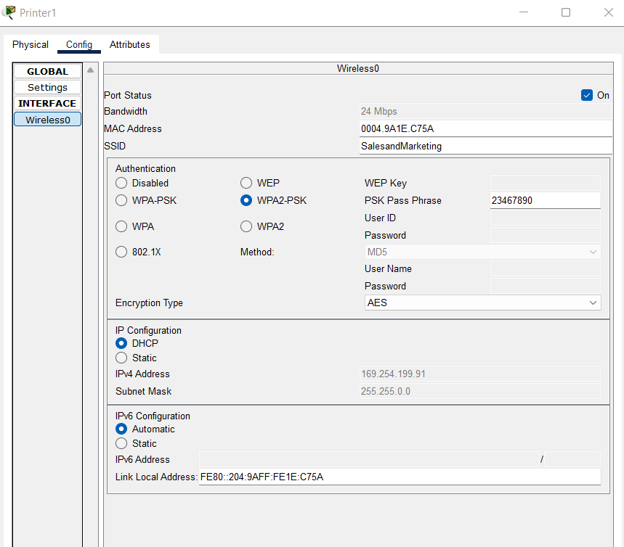
Department printer connecting to the access point. This configuration is repeated in all departments

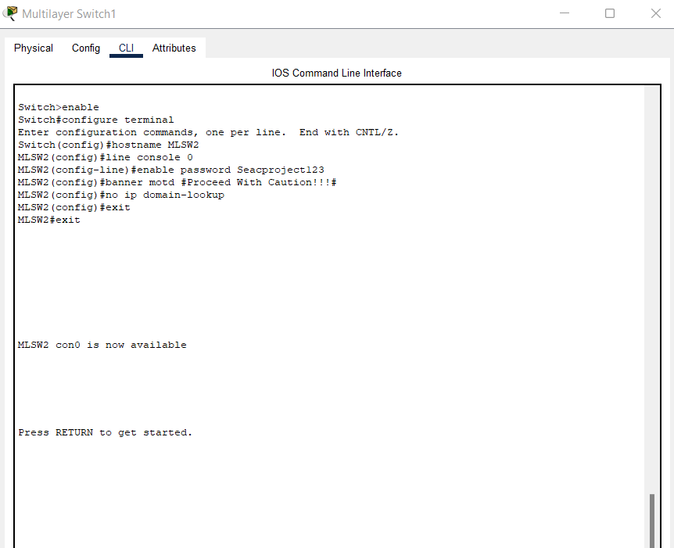

The basic configurations are done on the Multilayer switches

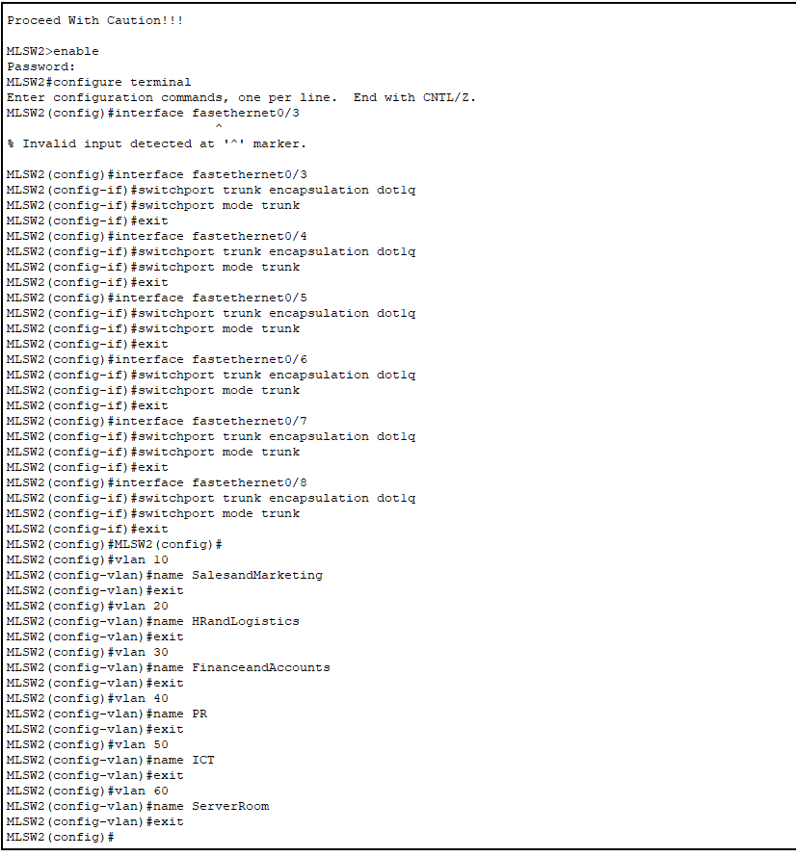

To enable the multilayer switches act as a layer 2 switch, the interfaces connected to the access layer switches are configured to have the encapsulation type as them and then for trunk function to carry multiple vlans, the vlans are also reconfigured on the multilayer switch for effective communication

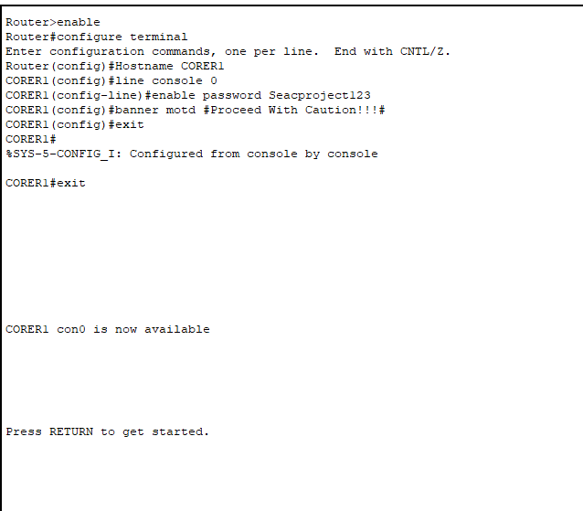

The basic configurations are done on the core routers

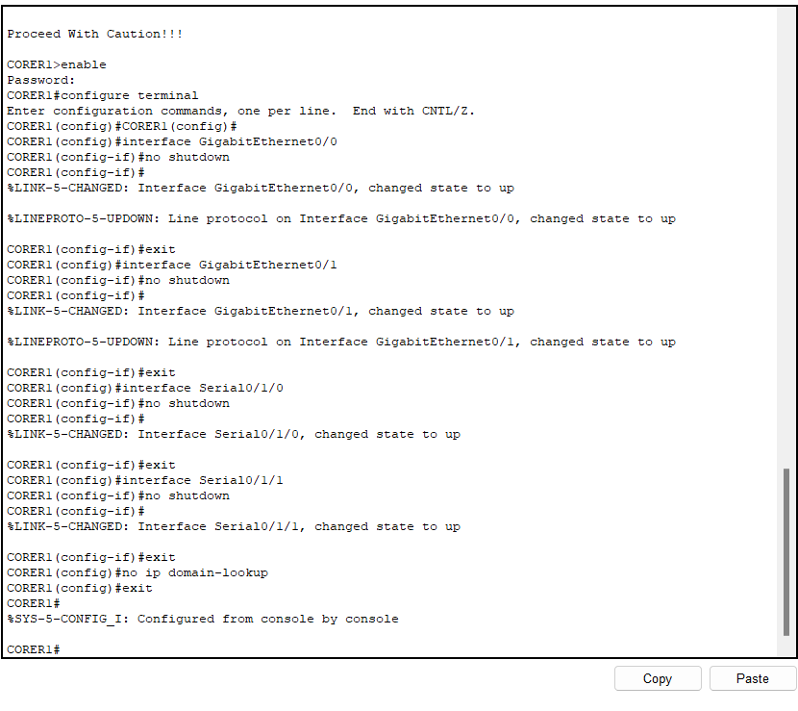
The no shutdown message is implicated on all cable interfaces in use to establish connectivity and the no Ip domain-lookup command is given

For each department 120 uses are expected, so with the formula of 2^n(n being number of hosts) we arrived at 2^7, which gives us a /25network bit that includes 128 hosts total with the first and last being unusable as they are for the network and broadcast address respectively.
For the server room 12 devices are expected , this gives us 2^4, which gives us a network bit of /28, this results in 16 total hosts with 14usable ip addresses
The routers and multilayer switch connectivity makes it to that the router shares an IP with the multilayer switch cable it connects to in the internal network and that is 4 interfaces;2 per router, which means that we need 2 hosts per router to switch interface, and that is 2^2 , that gives us a /30 bit ip address(of which we need 4), with 4 total hosts and 2 usable ip addresses.
With a base network of 172.16.1.0, we are working with a private class B IP address, which in this case is 172.16.0.0, the subnetting is as follows;

FIRST FLOOR
Sales and Marketing- 172.16.1.0/25 255.255.255.128
IP Range- 172.16.1.0 - 172.16.1.127
Usable ip range- 172.16.1.1-172.16.1.126
Human Resource and Logistics- 172.16.128/25 255.255.255.128
IP Range- 172.16.1.128 - 172.16..255
Usable IP Range- 172.16.1.129 - 172.16.1.254

SECOND FLOOR
Finance and Accounts- 172.16.2.0/25 255.255.255.128
IP Range- 172.16.2.0 - 172.16.2.127
Usable IP Range- 172.16.2.1-172.16.2.126
Public Relations- 172.16.2.128/25 255.255.255.128
IP Range - 172.16.2.128-172.16.2.255
Usable IP- 172.16.2.129-172.16.2.254

THIRD FLOOR
ICT- 172.16.3.0/25 255.255.255.128
IP range 172.16.3.0-172.16.2.127
Usable IP- 172.16.3.1 - 172.16.3.126
ServerRoom- 172.16.3.128/28 255.255.255.240
IP range- 172.16.3.128-172.16.3.143
Usable IP- 172.16.3.129 - 172.16.3.142

DISTRIBUTION AND CORE LAYER
MS1-R1- 172.16.3.144/30 255.255.255.252
IP Range- 172.16.3.144 - 172.16.3.147
Usable IP Range- 172.16.3.145-172.16.3.146
MS2-R1- 172.16.3.148/30 255.255.255.252
IP Range 172.16.3.148 - 172.16.3.151
Usable IP Range 172.16.3.149 - 172.16.3.150
MS1-R2- !72.16.3.152/30 255.255.255.252
IP Range- 172.16.3.152- 172.16.3.155
Usable IP- 172.16.3.153 - 162.16.3.154
MS2-R2- 172.16.3.156/30 255.255.255.252
IP Range- 172.16.3.156-172.16.3.159
Usable IP- 172.16.3.157 - 162.16.3.158

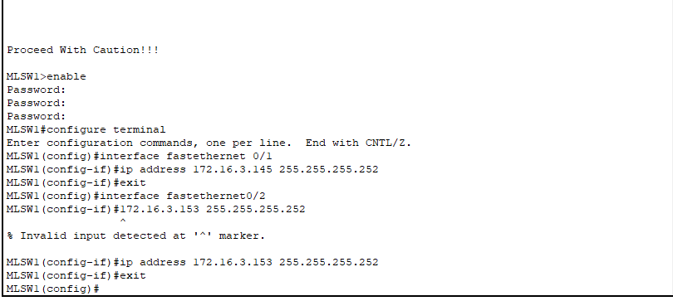

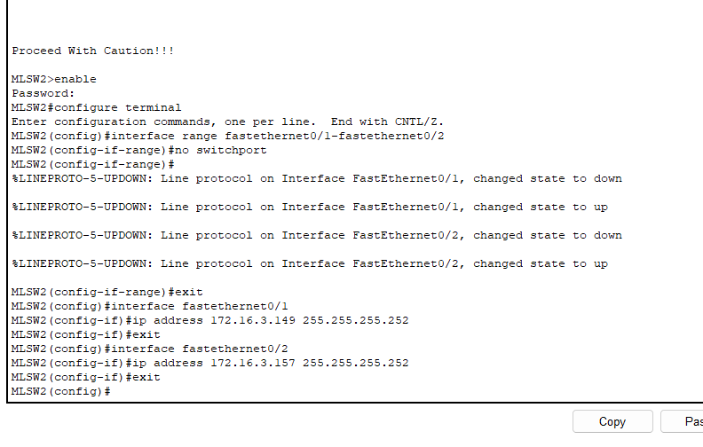
To enable IP address for the Multilayer switch a switchport command is given to allow for routing functionalities through the cable in question

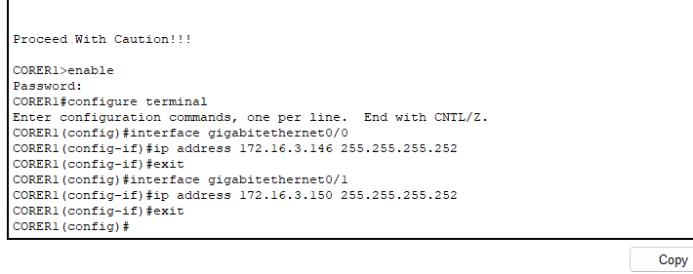

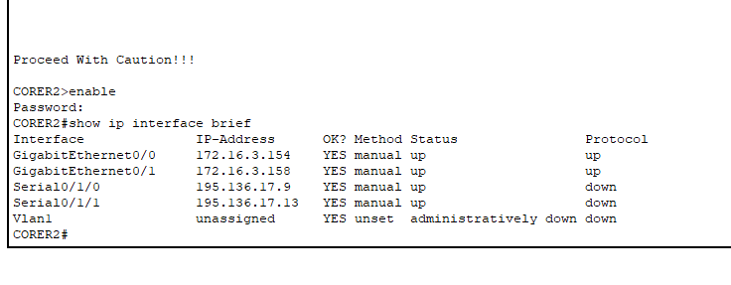
Static ip addresses are given to the Core routers and multilayer switches because it provides better stability and efficiency for the network as a whole as DHCP ips are typically used in end devices

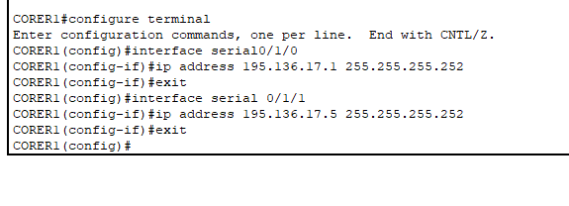

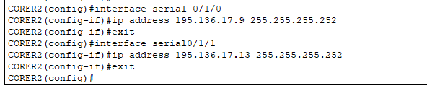
The Public facing interfaces of the Core routers (serial0/1/0 and serial0/1/1) are given IP addresses assigned by the ISPs as indicated by the requirements.
CORER1 SERIAL0/1/0-195.136.17.0/30
Usable IP-195.136.17.1 - 195.136.17.2
CORER1 SERIAL0/1/1- 195.136.17.4/30
Usable IP-195.136.17.5 - 195.136.17.6
CORER2 SERIAL0/1/0- 195.136.17.8/30
Usable IP-195.136.17.9 - 195.136.17.10
CORER2 SERIAL0/1/1- 195.136.17.12/30
Usable IP-195.136.17.13 - 195.136.17.14

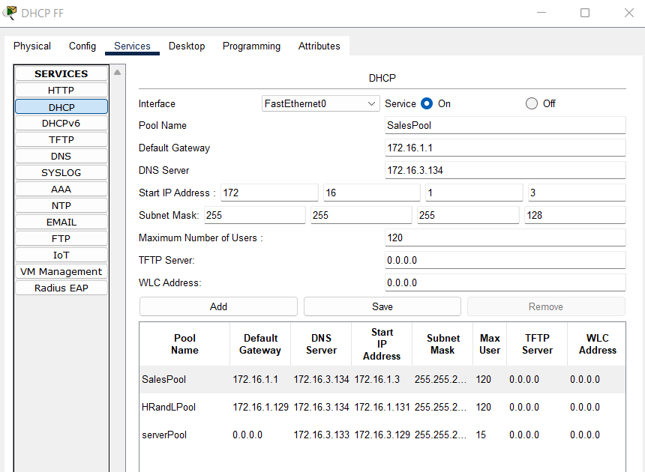

I cofigured a pool for the sales department and another for HR on a DHCP Server for the first floor

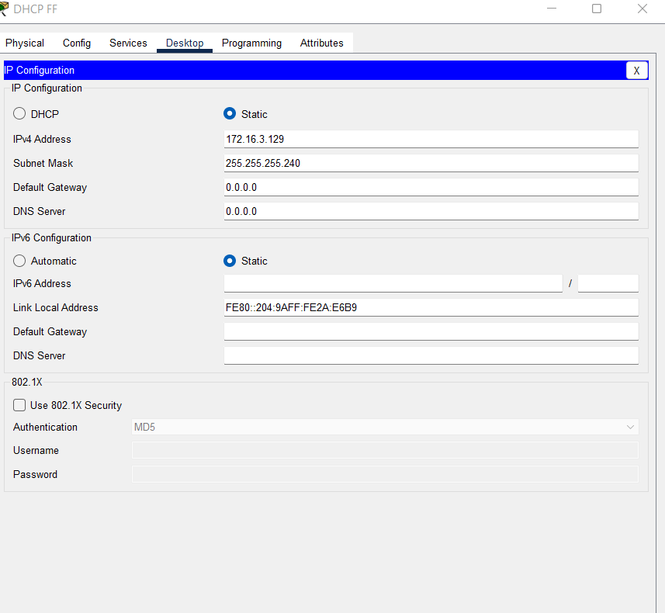

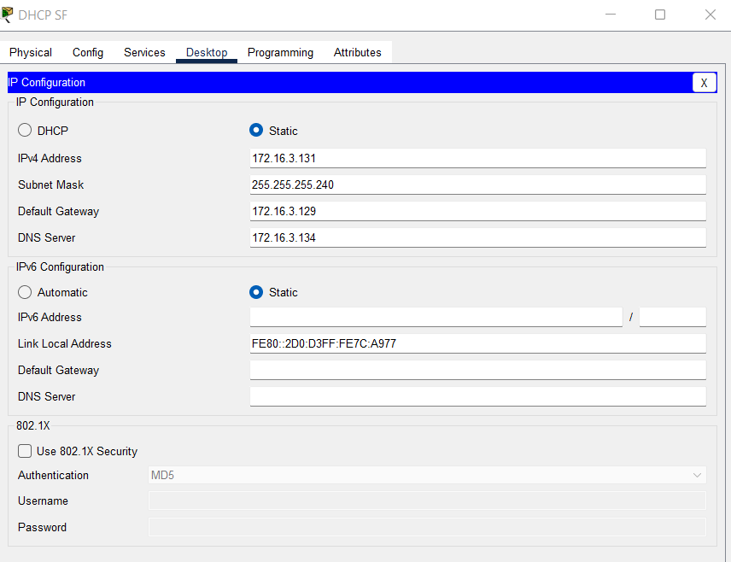

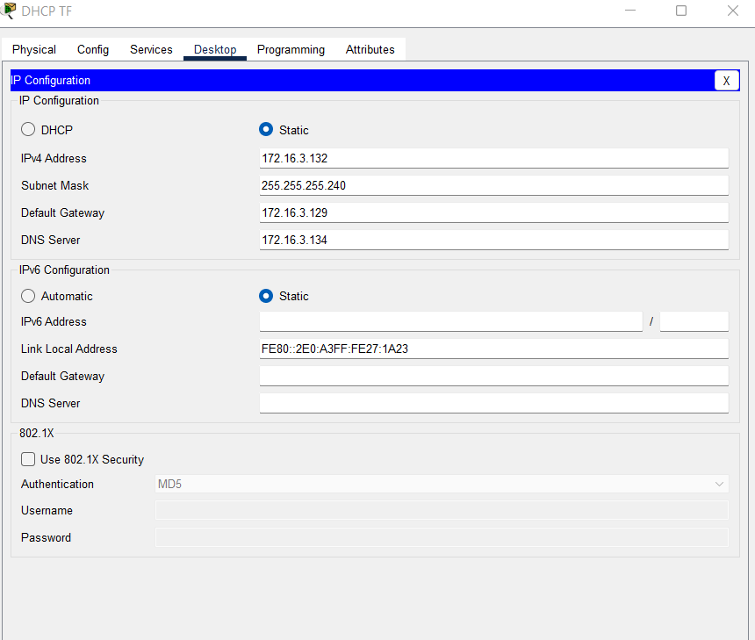

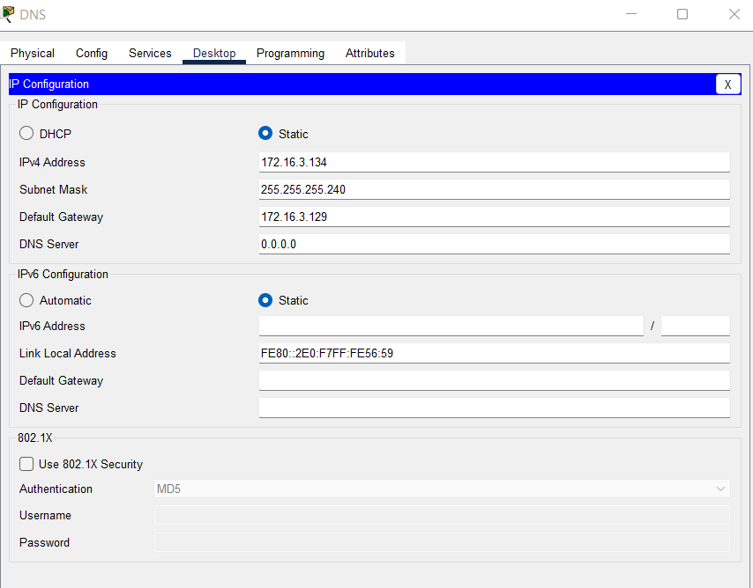

Static ip address are assigned for the Devices in the Server room, from the aforementioned IP range

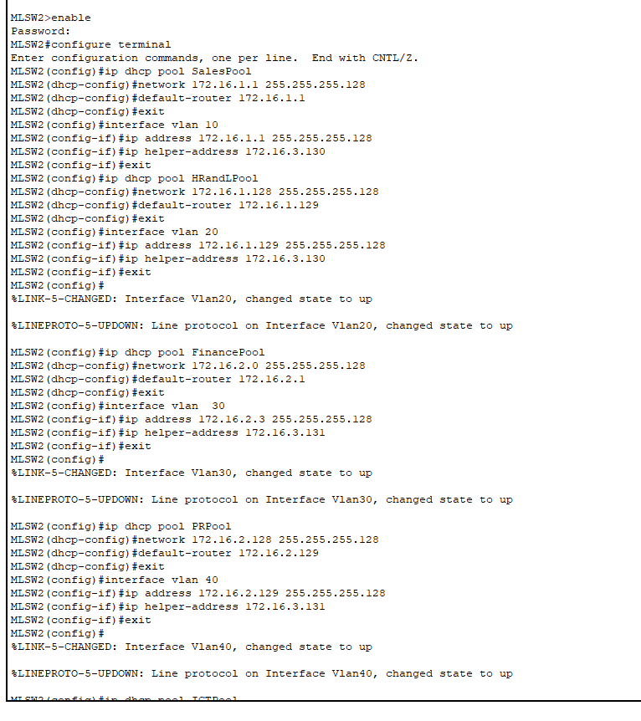

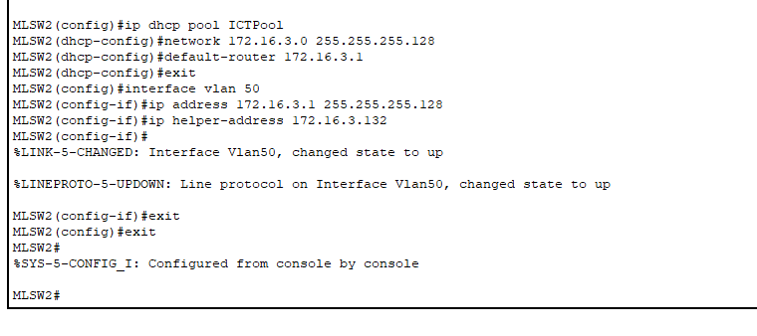
In the pictures above, the same dhcp pool from the DHCP servers are configured into the multilayer switch and then the the vlan interface is configured with the corresponding IP address and, the Multilayer switch is then used as a dhcp relay agent for means of the ip helper-address command , to help the vlan communicate with the neccessary DHCP server, thereby facilitating inter-vlan routing
This process is repeated on the second Multilayer switch in the network
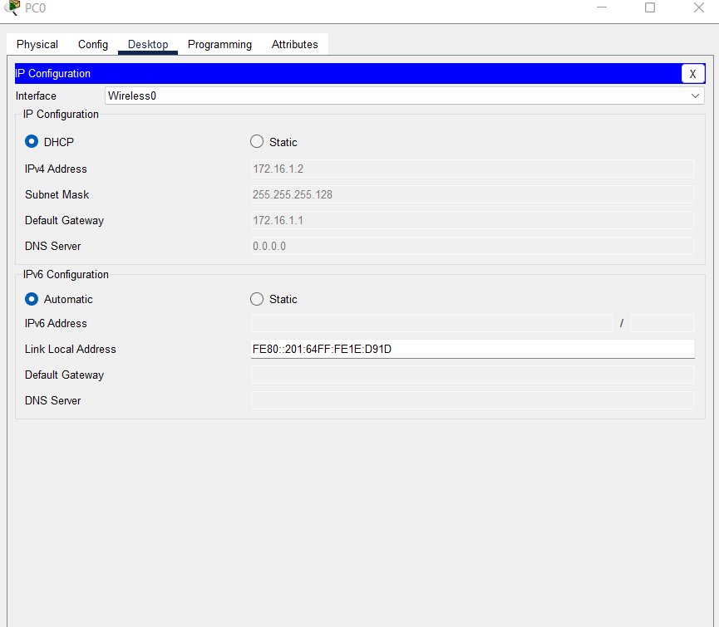
This shows DHCP IP addressing success in PC 0 of the Sales and Marketing department, proving DHCP IP addressing success in the department

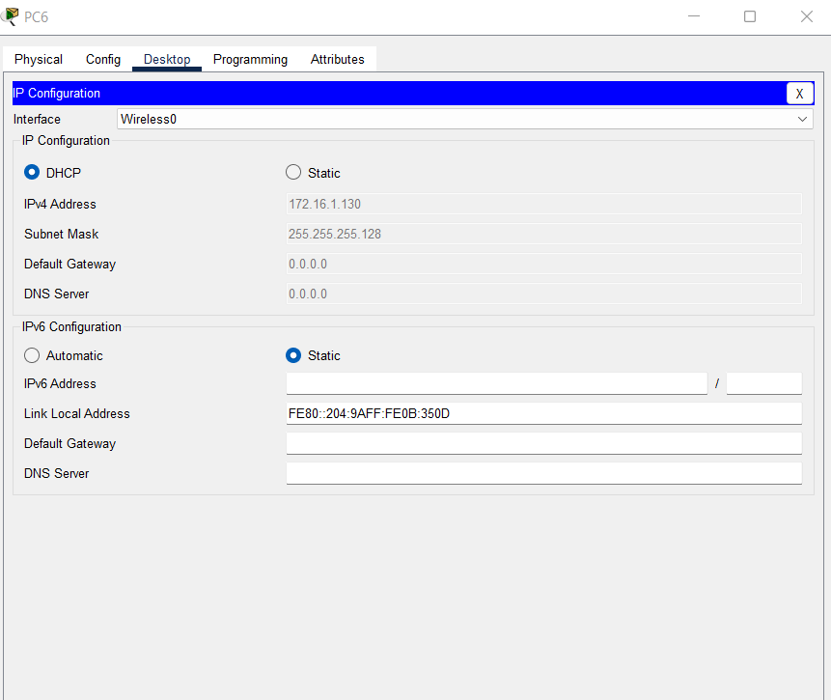
This shows DHCP IP addressing success in PC 6 of the Human Resource and Logistics department, proving DHCP IP addressing success in the department
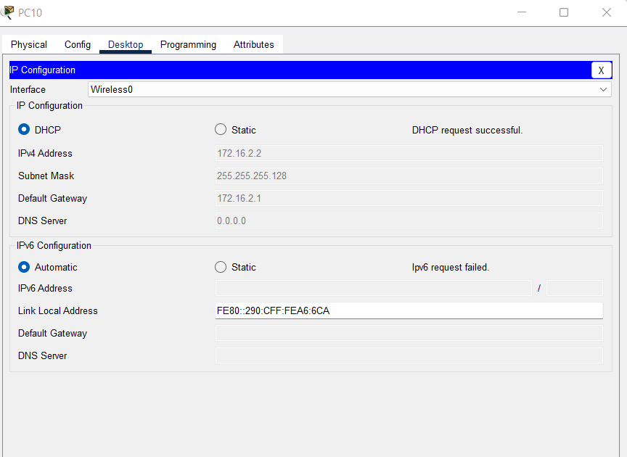
This shows DHCP IP addressing success in PC 10 of the Finance and Accounts, proving DHCP IP addressing success in the department

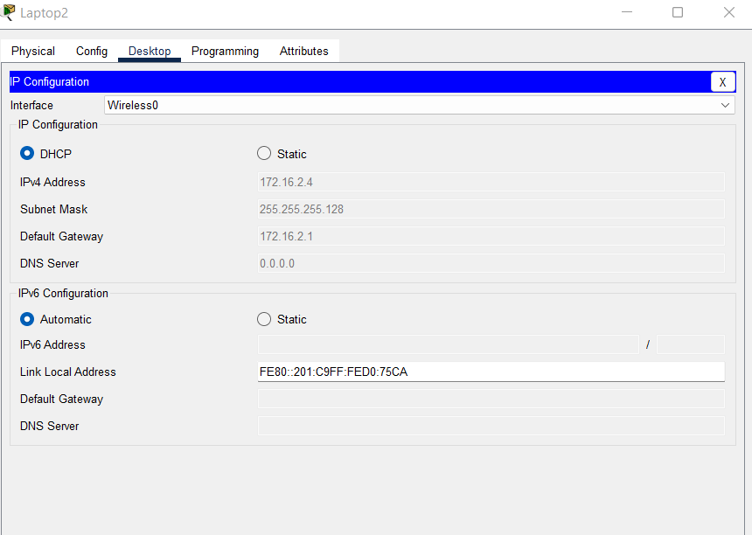
This shows DHCP IP addressing success in laptop 2 of the Finance and Accounts department, proving DHCP IP addressing success in the department

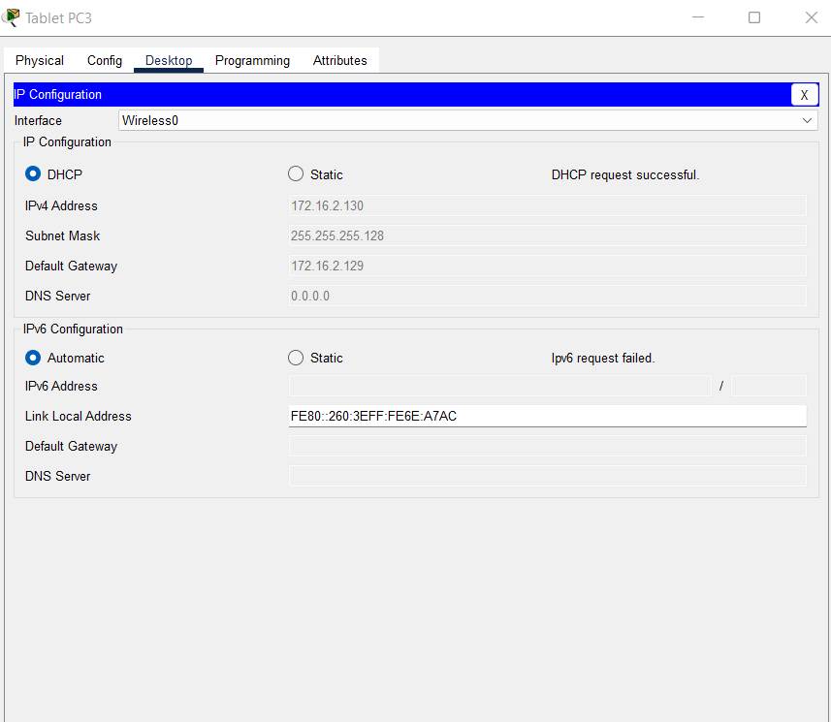
This shows DHCP IP addressing success in TabletPC3 of the Public Relations department, proving DHCP IP addressing success in the department

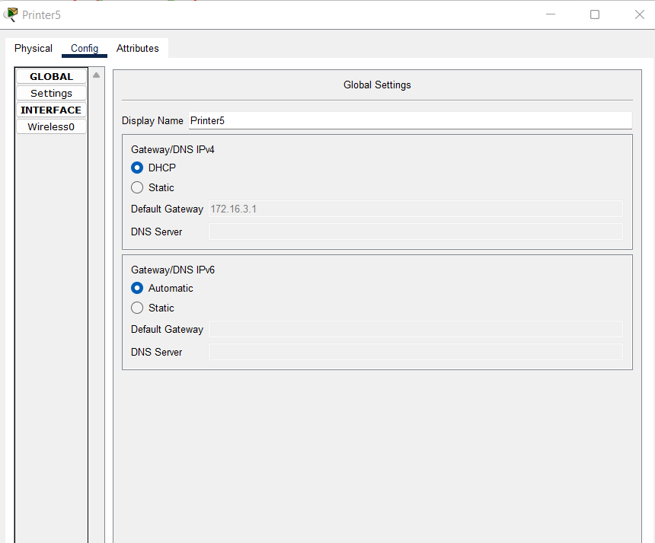
This shows DHCP IP addressing success in Printer 5 of the ICTdepartment, proving DHCP IP addressing success in the department

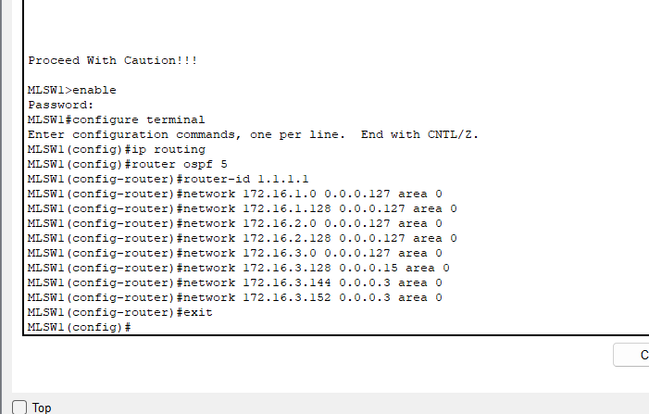

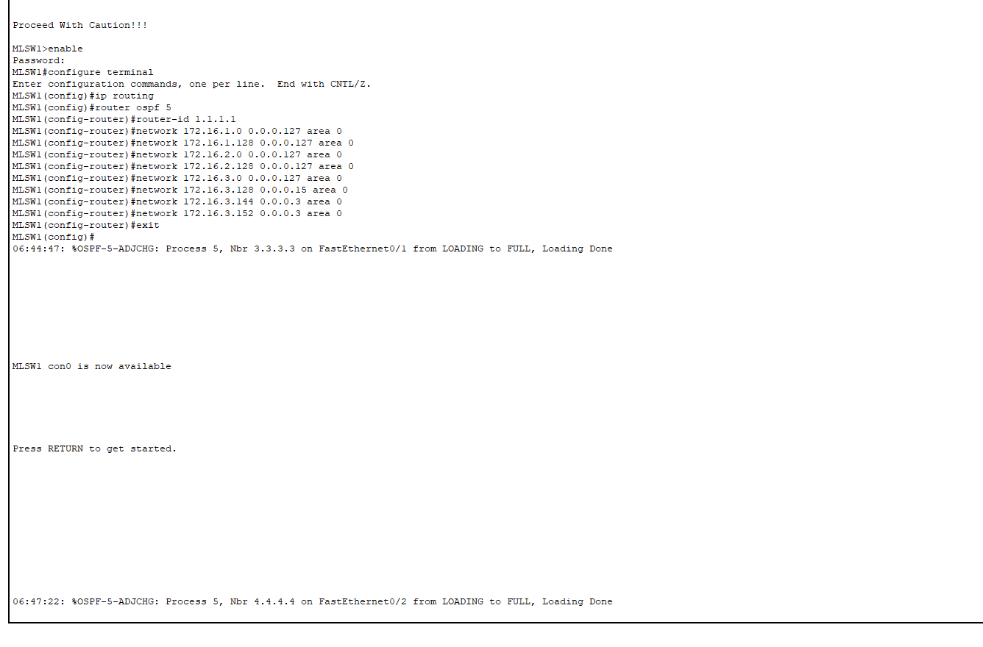

The picture above- shows the creation of ospf id, router id and then the advertisement of all the network addresses and their corresponding wild card masks attached to the cable nterfaces of the routers above, the router 1.1.1.1 which is the multilayer switch 0

It recognises the router id 3.3.3.3 and 4.4.4.4 form CORER1 and CORER2 respectively as neighbours in the OSPF link state of networks

open shortest path first is link state protocol, that links all the network address conncted to a router/layer3 switch to form and internal network to enable data travel through the most efficient route with area 0 representing the bacbone area
Nbr- neighbour recognises the neighbouring router IDs through the ospf ID and backbone area

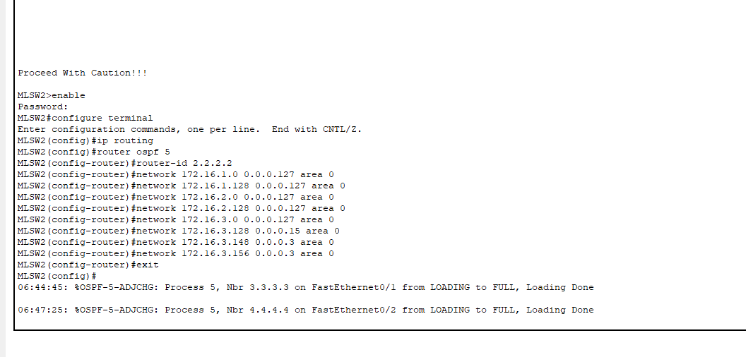
This image is for router 2.2.2.2 which is the multilayer switch 1.
It recognises the router id 3.3.3.3 and 4.4.4.4 form CORER1 and CORER2 respectively as neighbours in the OSPF link state of networks

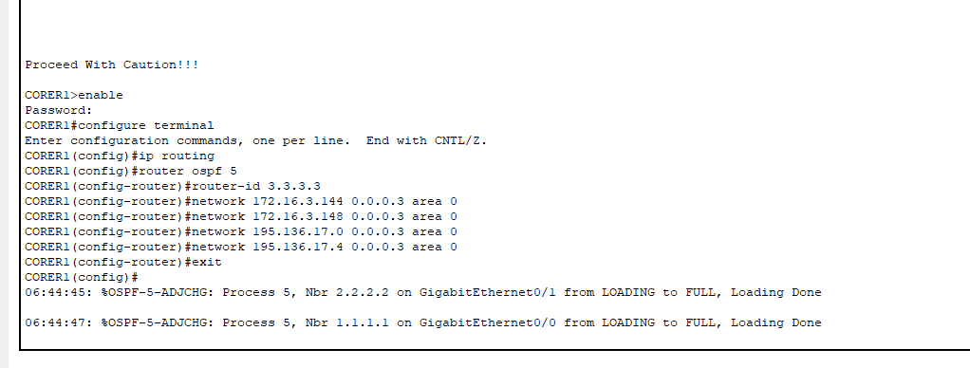
This image is for router 2.2.2.2 which is the multilayer switch 1.
It recognises the router id 1.1.1.1 and 2.2.2.2 form MLSW1 and MLSW2 respectively as neighbours in the OSPF link state of networks

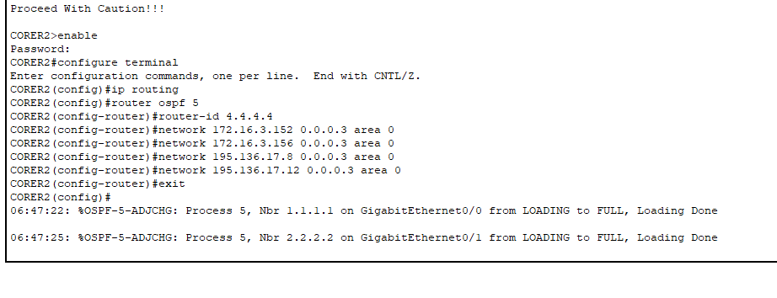
This image is for router 2.2.2.2 which is the multilayer switch 1.
It recognises the router id 1.1.1.1 and 2.2.2.2 form MLSW1 and MLSW2 respectively as neighbours in the OSPF link state of networks

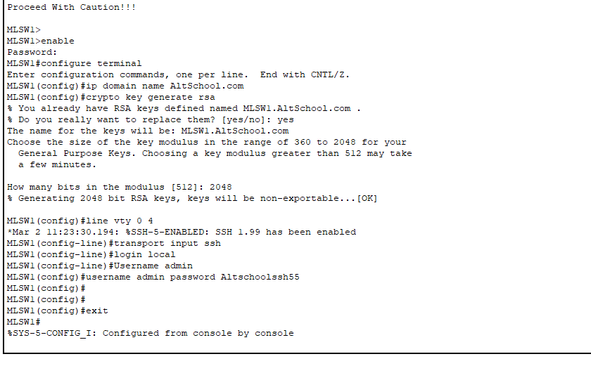
Secure shell protocol(ssh) is used to generate an rsa key. This creates a secure tunnel for remote login between an end device and a router on the local network and enables secure secure communication .This utilises the layer 3 routing function of the multilayer switch. A username and password is created for login purposes
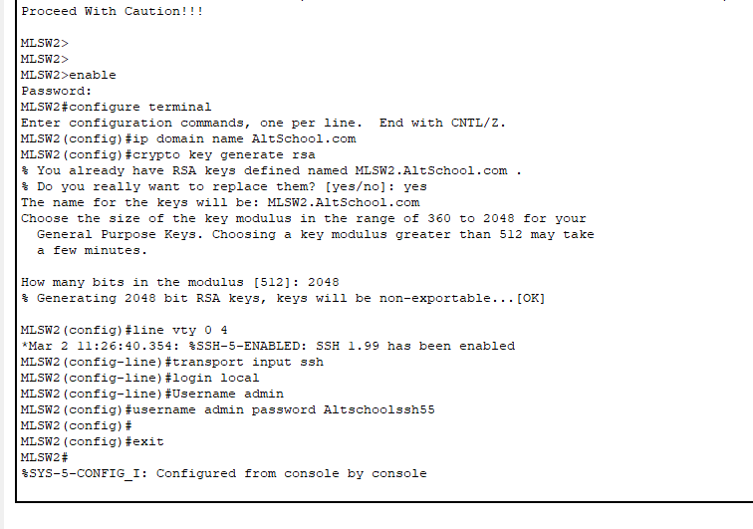
Secure shell protocol(ssh) is used to generate an rsa key. This creates a secure tunnel for remote login between an end device and a router on the local network and enables secure secure communication .This utilises the layer 3 routing function of the multilayer switch. A username and password is created for login purposes

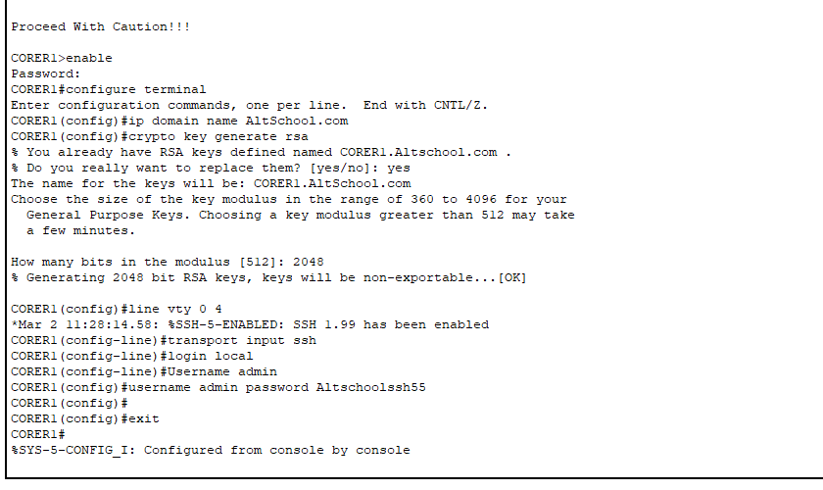
Secure shell protocol(ssh) is used to generate an rsa key. This creates a secure tunnel for remote login between an end device and a router on the local network and enables secure secure communication . A username and password is created for login purposes

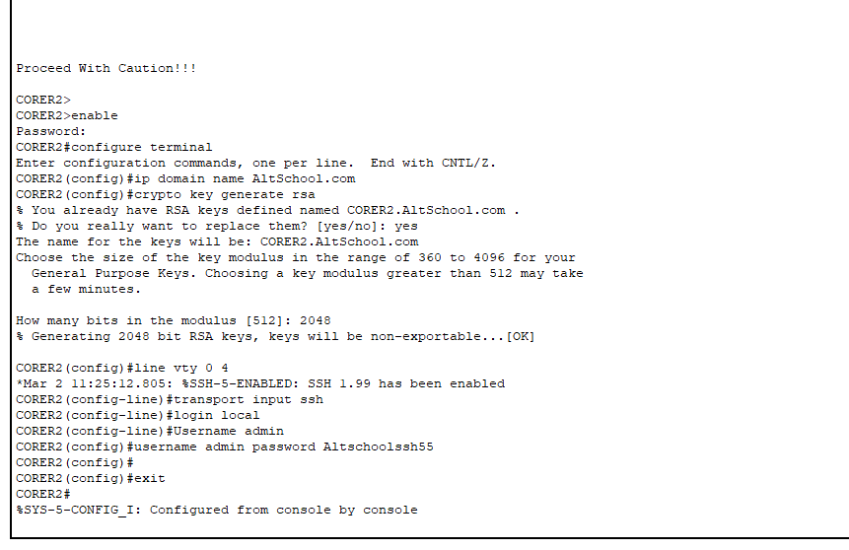
Secure shell protocol(ssh) is used to generate an rsa key. This creates a secure tunnel for remote login between an end device and a router on the local network and enables secure secure communication . A username and password is created for login purposes

Username and password of all ssh rsa keys created on the routers and layer 3 switches are the same for the purpose of redundancy

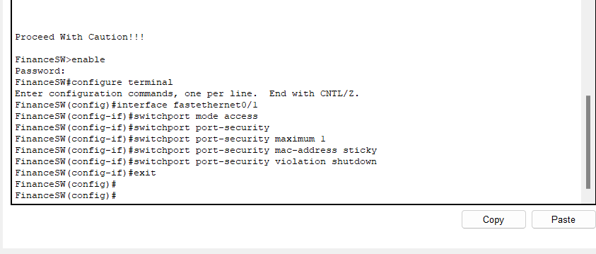
Switchport security enables the configuration of security protocols on the designated switch ports, this one is done in the in the layer 2 Finance and Accounts Deepartment switch.
It allows only a maximum of 1 mac-address dynamiccally selected by the port throught the ‘sticky’ protocol to connect to the switchport.
In the the event of a violation of the 1 mac-address security protocol a shutdown protocol is issued which disables the connection of every device in the department to the corresponding switch and also to the rest of the network

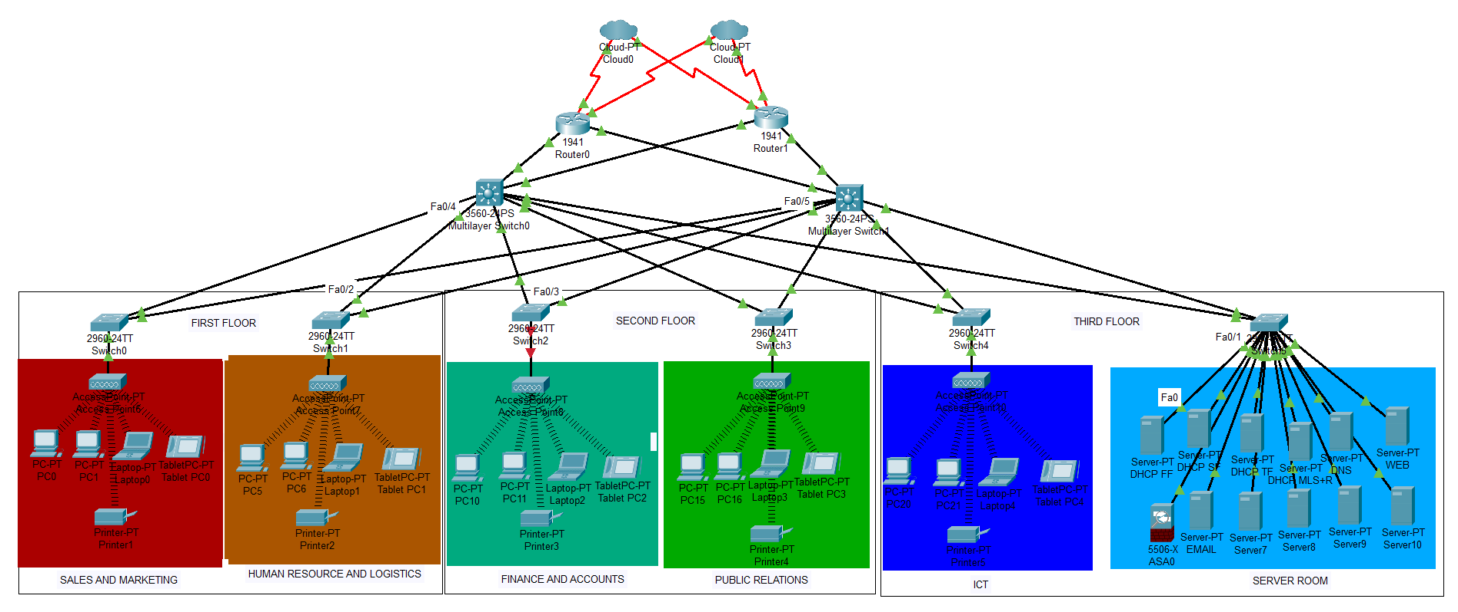
This shows the a shut down of the switch and access point interface cable after the switchport security protocol indicated by the red arrows
A fix for this result would be statically assign the mac-addresses that can connect to the switchport

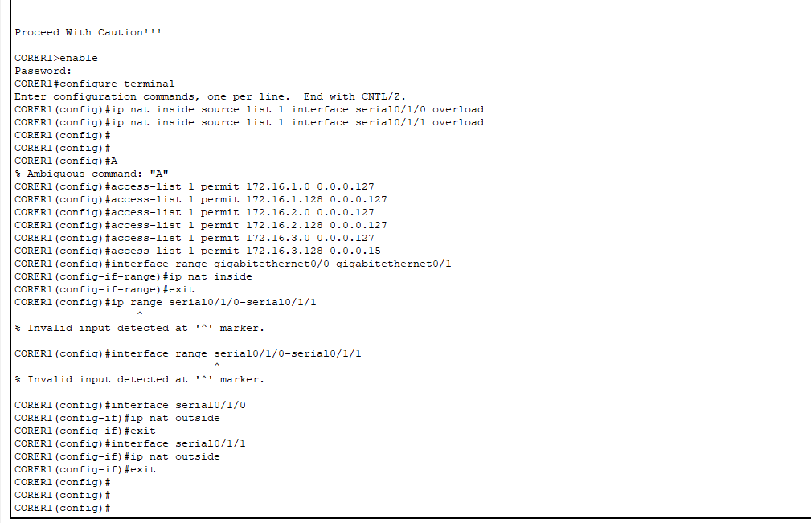

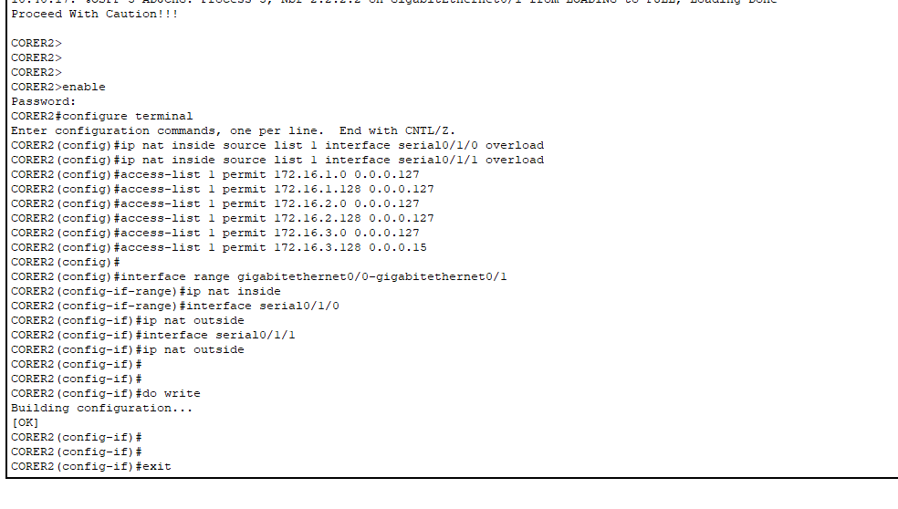
The IP NAT (PAT) allows multiple internal network ip addresses to connect to a public IP address
The Accest-control list here permits which network addresses within the internal network connect to the public IP
This configuration is done within the on the outbound router interfaces and specifiex with interface cables are for internal network traffic( ip nat inside) and outbound network traffic( IP nat outside)
This is done on the CORER1 and CORER2

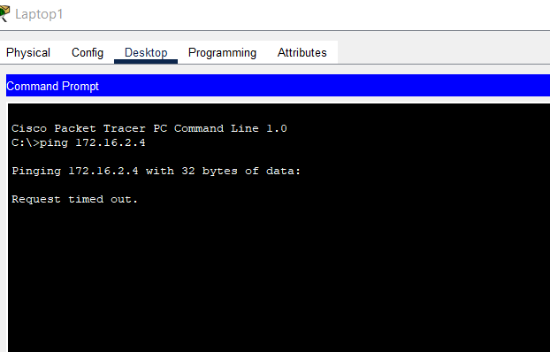
Failed Ping from a laptop in the Human Resource and Logistics Department to a device in the Finance and Accounts Department

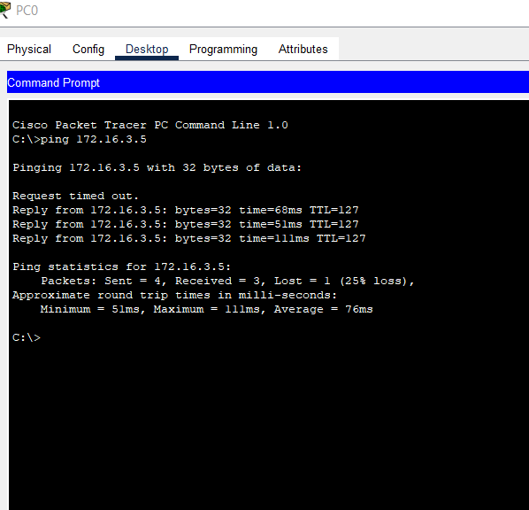

Successful ping from device in the Sales and Marketing Department to a device in the ICT department

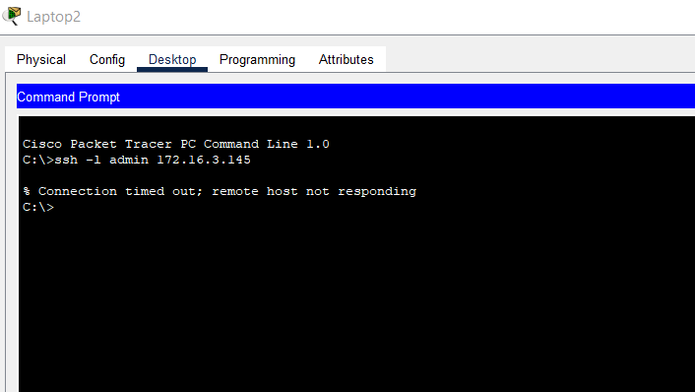

Failed attempt from device in Finance and Accounts to secure remote access to MLSW1 through the remote access ssh protocol

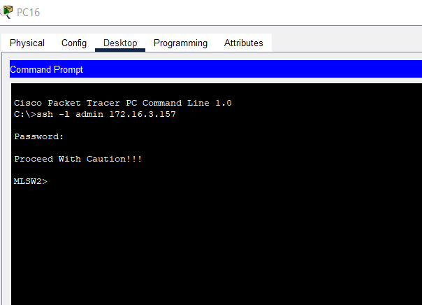 successful attemp of device in the Public Relations Department to access the MLSW2 through the remote access ssh protocol

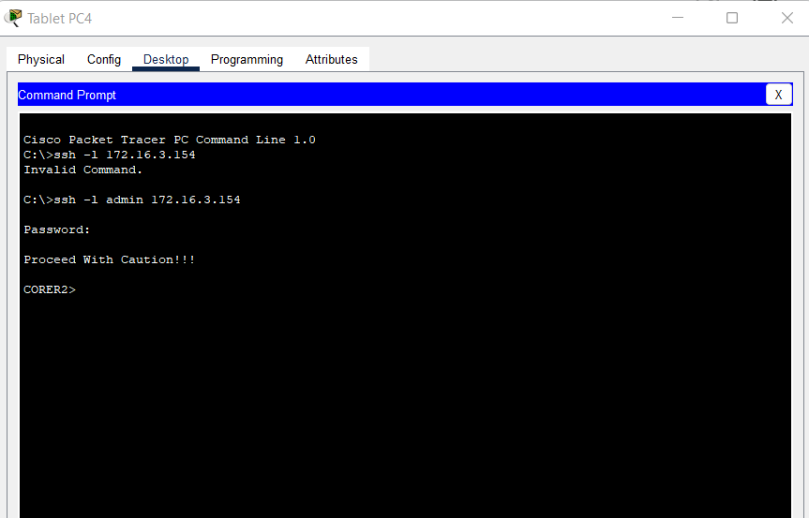
Successful access of the ICT TabletPC4 tp access the CORER2 through the remote access ssh protocol

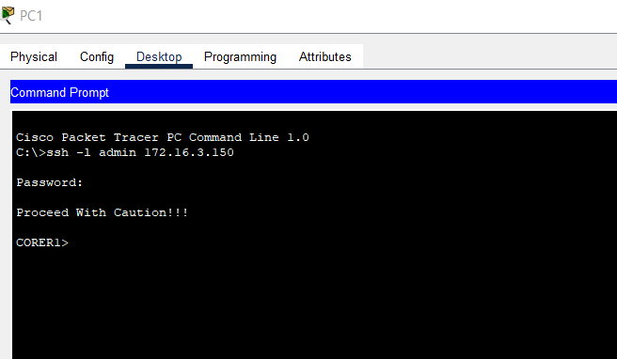
PC1 from the Sales and Marketing departments has remote access to the CORER1 through the ssh protocol.

